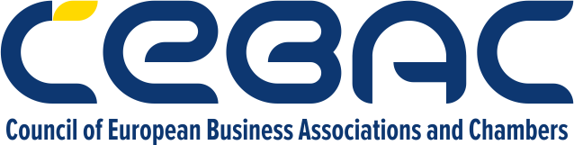

AGENDA – CBAM WORKSHOP

30.10.2025, European House (Evropska kuća), Zmaj Jovina 8
9:00 - 9:30, Lower ground floor, Schuman space
WELCOME PARTICIPANTS

9:30 - 10:00, Schuman space
OFFICIAL INAUGURATION CEREMONY
Pasquale de Micco, Head of the European Integration and Economic Section, EU Delegation in Serbia
Silvija Rakić, CEBAC Secretary general
Nataša Obradović, Chair of the ESG committee and Legal Avisor to CFO, Telekom Srbija

10:00 - 10:20
INTRODUCTION: CBAM Legislation overview
Filip Živanović, ESG committee co-chair, law office Nikčević Kapor

10:25 - 11:25
ROUND TABLE: Companies’ successful practices
Participants: Čaba Molnar (Galeb Metal Pack), Dušanka Busić (Milsped), Aleksandar Obradović (ZF), Miroslav Gligorijević (Titan)
Moderator: Jovan Babić, Certification manager and ESG committee co-chair (Bureau Veritas)
11:25 - 11:35
Q&A

11:35 - 12:30, Schuman space
COFFEE & NETWORKING, powered by Lavazza

